# Guide for using tensorflow in Linux (Ubuntu 16.04 LTS) environment

## Installing Tensorflow

Follow the steps in the link <https://www.tensorflow.org/install/pip>

* Note: Do not install the alpha 2.0.0 version as it is not stable yet.

I have installed anaconda which consists of python and other libraries.

<https://www.digitalocean.com/community/tutorials/how-to-install-the-anaconda-python-distribution-on-ubuntu-16-04>

* Note: Follow this guide before installing and running tensorflow.
* Note: Commands for creating a virtual env changes if you are using anaconda.

🡪Remember to change the directory to **/tmp** before activating the virtual environment again and running tensorflow.

🡪source activate my_env

🡪source deactivate

Tensorflow and python (anaconda) installed and running on a Linux Ubuntu 16.04 LTS VMware workstation. Testing of the first sample program below shows the tensorflow is working without any errors.

Try some sample codes to understand the tensorflow. Follow the guide. <https://www.datacamp.com/community/tutorials/tensorflow-tutorial>

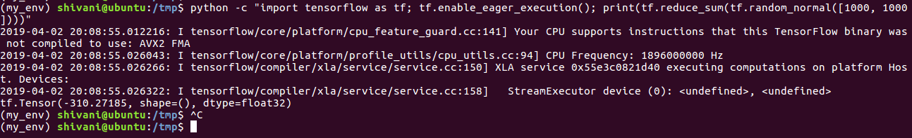

Really basic arithmetic functions for understanding

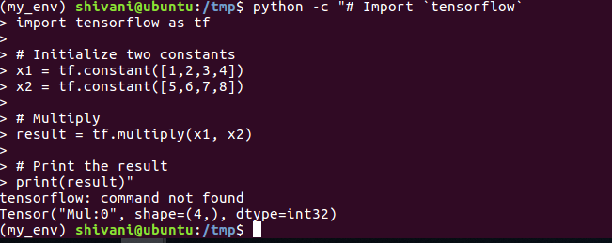

The above code result only defines the model but does not actually calculates. To verify the calculation, I am running the code in an interactive mode.

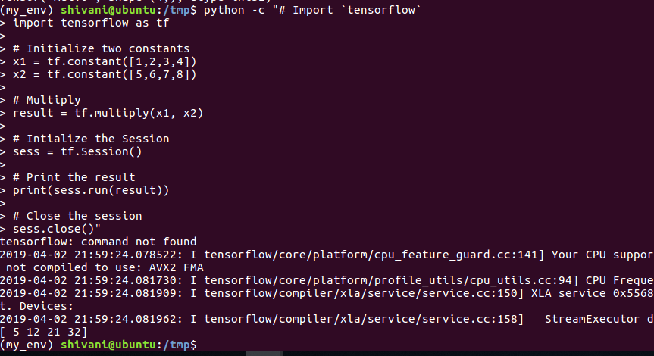

Can get the information of the CPU or GPU by using this command in session information

Config=tf.ConfigProto(log_device_placement=True)

Config=tf.ConfigProto(allow_soft_placement=True)

## Loading and Exploring the DATA

Download the data files. Change the Root path and sub directories.

* NOTE: Add the import files for the code to run properly. The below code will run properly without any error.

import os

import skimage

from skimage import data

from skimage.data import imread

def load_data(data_directory):

directories = [d for d in os.listdir(data_directory)

if os.path.isdir(os.path.join(data_directory, d))]

labels = []

images = []

for d in directories:

label_directory = os.path.join(data_directory, d)

file_names = [os.path.join(label_directory, f)

for f in os.listdir(label_directory)

if f.endswith(".ppm")]

for f in file_names:

images.append(skimage.data.imread(f))

labels.append(int(d))

return images, labels

ROOT_PATH = **"/home/shivani/"**

train_data_directory = os.path.join(ROOT_PATH, "**TrafficSigns/Training**")

test_data_directory = os.path.join(ROOT_PATH, "**TrafficSigns/Testing**")

images, labels = load_data(train_data_directory)

Issues faced during the code execution:

* Utils library can not be find.